Code Screen Dumps

The Main Window
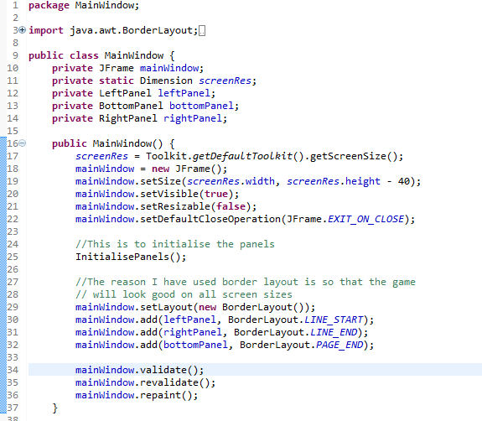
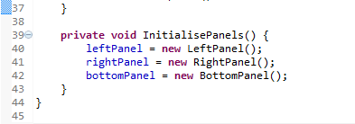
Initializing the panels
Setting up the main Window and adding in all of the panels

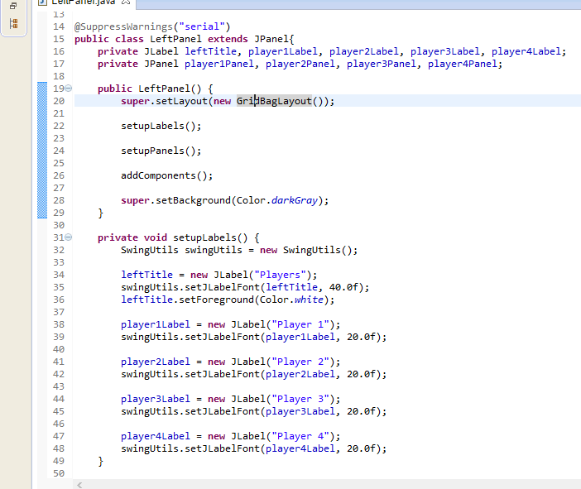
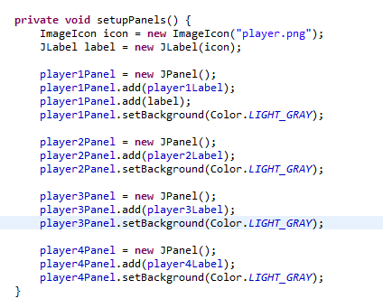
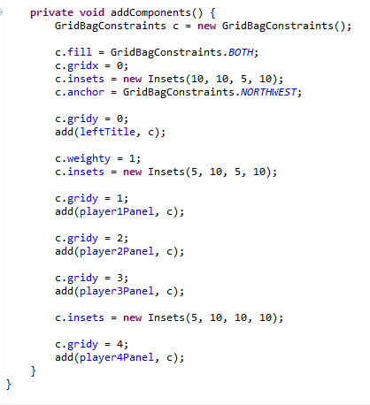
Setting up the left Panel of the User Interface

Setting up the Right Panel of the User Interface
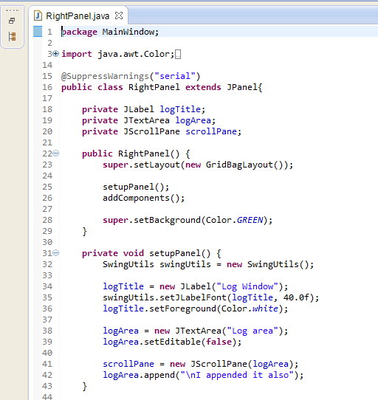
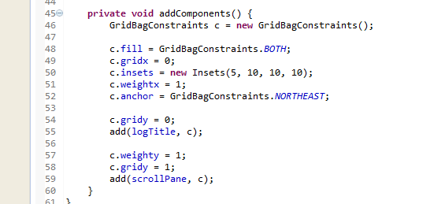

Setting up Bottom Panel of User Interface
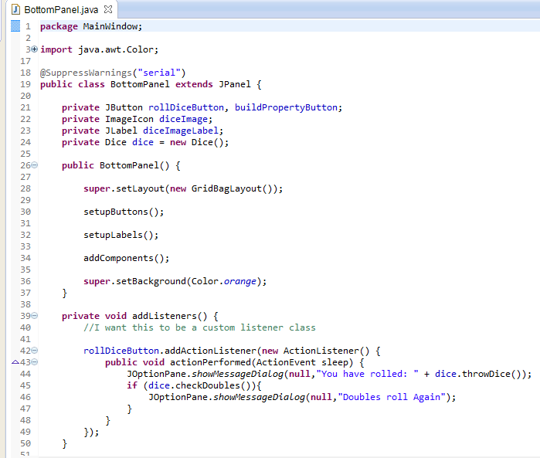

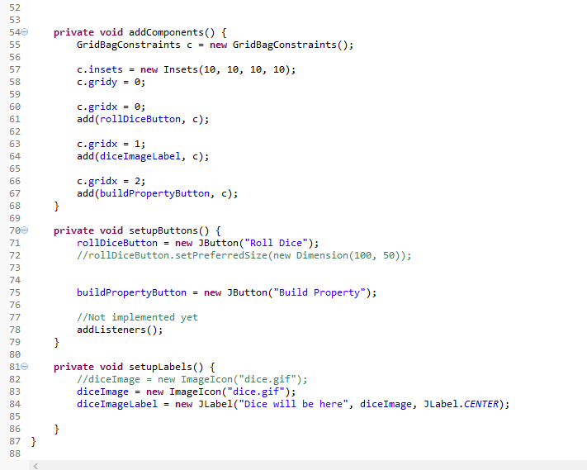
Early version of an action listener for the roll dice button is displayed here. Images of its function

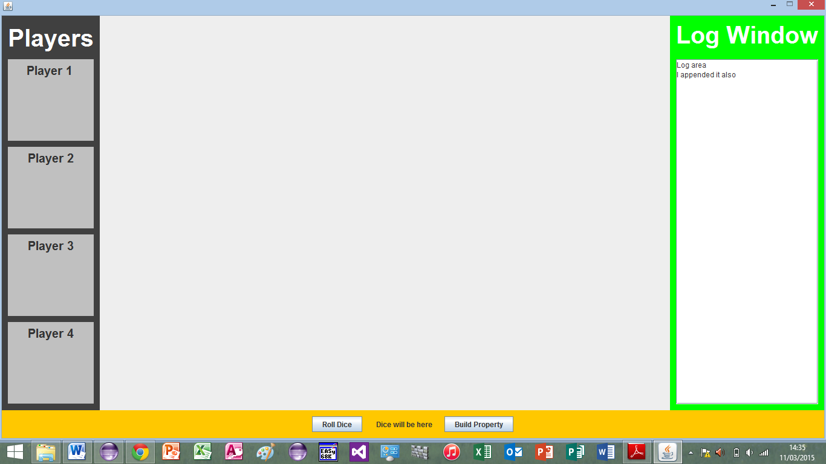
The Running Code
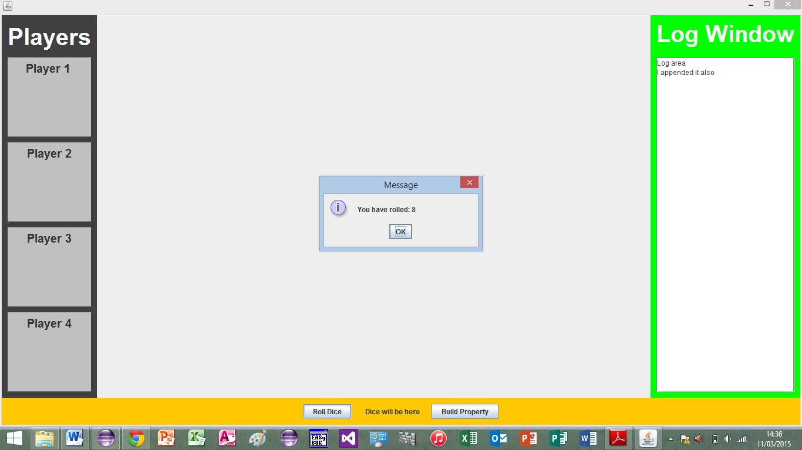

Property Class
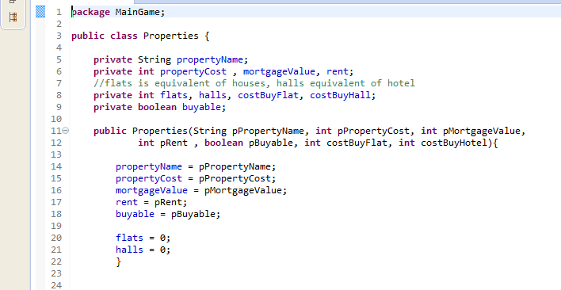
This is the property class constructor which includes all of the different attributes that each property may have, as the project continues we may decide we need more or less of these. Each of the variables has a getter and setter method attached to it. There is also some methods that perform calculations like the one displayed below
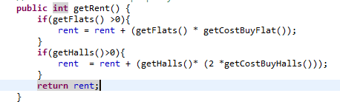
This method calculates the rent of a property; the rent can either be standard or can be increased by the number of ‘halls’ of ‘flats’ that are attached to the property.

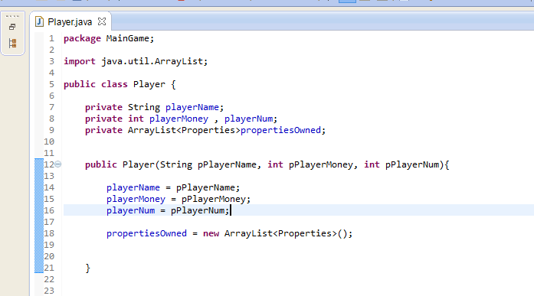
Player Class

This is the player class constructor, as seen above the properties that the players own will currently be stored in an array list.
Getters and setters have been implemented for all the variables shown above.

Dice Class
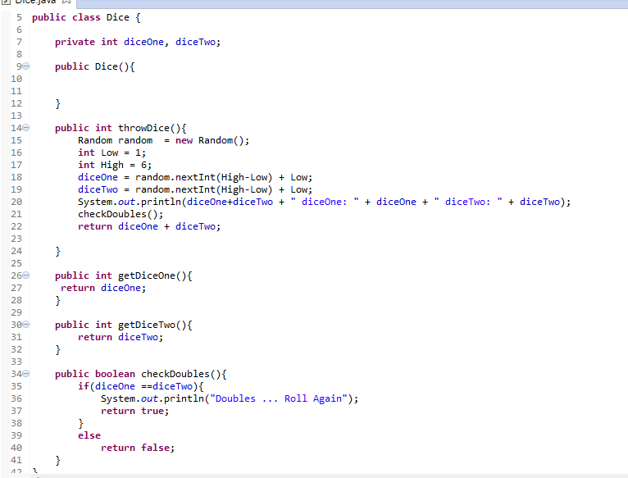
Above is the dice class which will display what value each dice is along with their total value, it will also check to see whether the value of the two dice are the same, if they are then the user will be instructed to roll again

Testing
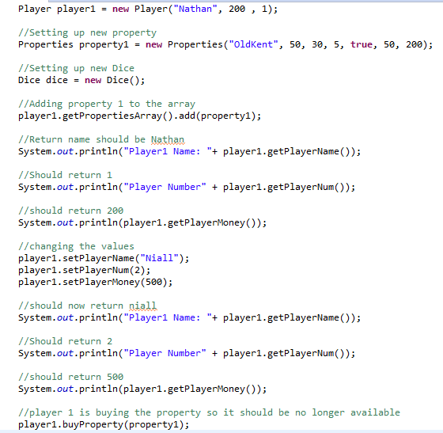

Testing the methods involved with the player class, the comments show what should be displayed in the console area. The console areas results are displayed below:
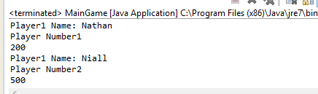

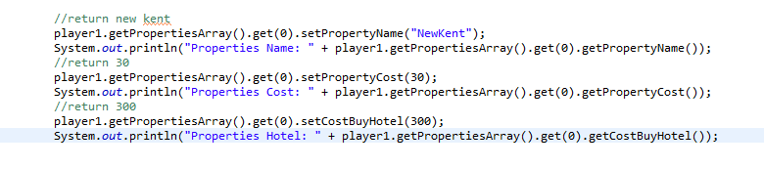
Testing some property methods, the comments display what expected output should be. The console results are below:
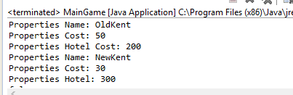
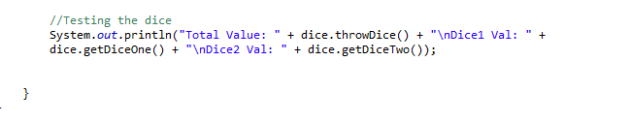

Testing the dice two display two random numbers and adding them up
